**Chapter 1**

**PROBLEM AND ITS BACKGROUND**

**Project Context**

Developing a technology for the company’s productivity should be the main concern of the developer. As stated, the state shall give priority to research and development, invention, innovation, and their utilization Online Ticketing System will help the company in terms of tracking the problems, management of request. Online ticketing system will help a lot in the process of company and easily response.

Fortis Technologies Inc, expertise in hardware, software, and people are value in their proposition, offering end to end solutions to the entire information technology stack. Fortis Technologies focus on emerging and innovative technologies and company’s breadth of integration expertise encourages close cooperation with company’s key technology partners.

The researcher conducted a research and learned that the developers of Fortis Technologies Inc. receives an average of 100 and plus of emails of the clients of the company requesting for support every day. The developers of the company is using g-mail to

receive and respond to the e-mails sent by the clients of the company. In the current process of the Fortis Technologies Inc. the developers of the company encountered the problem in monitoring the requested e-mail by the clients. The developers of the company sometimes overlook some emails sent by the clients and some also were ignored. The developers of the company can’t properly manage

the received request e-mails, the developers of the company sometimes don’t know that the other developers is also working on the same requested e-mail at the same time.

Therefore, the researchers decided to create an Online Ticketing System for Fortis Technologies that will help the business process of the Fortis Technologies. The Fortis Technologies can easily identify the problems and will easily response to the client’s request.

**Purpose and Description of the Project**

The purpose of creating an Online Ticketing System is to help and enhance the effectiveness of the Fortis Technologies Corporation, to easily monitor and identify the mails, issues, status of the ticket. That will increase the subscriber for Fortis Company.

The Online Ticketing System can track the problem that was requested by their clients and the Fortis Company Administrator can easily track or monitor who is assigned in one particular task that the client sent. The client can easily check or monitor the status of their requests. The client of the Fortis Technologies Corp can create comments to the issue. The request will be kept for future reference and will be monitored even if the developers solved the problem.

Capabilities of the proposed system:

1. **The Company.** Online Ticketing System can help the Fortis Technologies Inc. to easily respond to the problem was requested by their clients.
2. **The Employees.** can easily handle the problems that are being reported by their clients.
3. **The researchers.** can enhance and improve their skills to resolve and learn about different problem in implementing the system, and the proponents are updated on what is happening in the industry.
4. **The Future Researchers.** The benefits for the future researchers are by getting an idea for develop a system is when the future researchers read the documents about thesis project. The future researchers also get encourage and motivation by developing a system when the future researches read about the review of related literature and study.

The target of the proposed Ticketing System is the Fortis Technologies Inc. developers. The beneficiaries of this system are:

**Objective**

This study aims to develop a Ticketing System for Fortis Technologies Inc. to easily track and report the problem progress. Developing a technology for the company’s productivity should be the main concern of the developer. As stated, the state shall give priority to research and development, invention, innovation, and their utilization have a good service for the clients who will inquire to the website and the services such as support process.

**General objectives**

This study has the following specific objectives:

1. To create a module which the clients of Fortis Technologies Corp. can send requests.
2. To create a module that will show the status and severity of the ticket requested by the client.
3. To create an administrative module that will let the administrator to monitor how fast the developers of Fortis Technologies Corp respond on one specific request.
4. To reduce the delay on the response on the issue send by the client.
5. To design an interface for the Administrator Developers and the Users.
6. To create maintenance user account module for the administrator.
7. To create and develop a module for the messages of the users.
8. To create a notification module for the Administrator, Developers and the Users entity.
9. To give clients a satisfaction regarding Online Ticketing System.

**Scope of the Project**

The proposed project of the researchers is capable of creating issue or tickets which will be created by the clients, the clients can also view the progress of the tickets they have created. The clients can add comments to give their feedbacks on the support of the company.

The users of the system needs to login to access the system, users can view tickets and assign to them solves to fixed the problems. The users can also update the status of the ticket that were assigned to him/her according to the resolution they made.

The Administrator of the system is capable of adding, update and deleting of user accounts in the system, the administrator can add, edit and delete in the maintenance module. The administrator also can view the tickets, assign to him/herself or assign to a specific person, he/she can monitor how do the support team response to the clients, he/she can monitor the statistic many tickets they have taken and resolved.

**Chapter 2**

**REVIEW OF RELATED LITERATURE & STUDIES**

This chapter presents the related literature and studies, both foreign and local which are relevant to the present study. The researchers made use of materials that provide sufficient information related to the study such as books, magazines, internet, unpublished thesis and other technical reports.

**Related studies**

According to **Johanna Ivarsson (2013)** in her case study of an IT Helpdesk service, to solve the service quality issues this study recommends starting to work with measurability and continuous improvements, for example Lean Six Sigma. The IT department can strive to increase the interdepartmental communication, share work tasks, educate internally, document competences and clarify responsibilities to decrease the workload.

This statement influences us why the proponents decided to create a website that will help the company to lessen the workload of the developers.

According to **Knapp (2013)** consequently, help desks have evolved into service desks. Furthermore, the most critical issues faced by organizations in the service desk environment pertain to: (1) the structure of the service desk; and (2) how to improve user support.

The researcher’s apply this by putting a brief introduction about their service, and influences the researchers to develop more efficient and effective Ticketing System. The researchers added a comment section where the client can able to communicate to the developers of the company.

According to **Abdinnour (2011)** the virtual service desk became prominent when networking capabilities increased. In the virtual service desk structure, end users get the impression of a single, central service desk when in fact the service desk representatives may be using online.

This statement by Abdinnour strengthens the researcher’s decision and provides a better idea of how the system will look and may give their clients a satisfaction in using the Ticketing System.

**Related Literature**

According to **(Jantti 2013).** The literature pertaining to management servicedesks encompasses the implementation of self-help knowledge management systems.

With this study, this kind of system helps the company a lot especially in monitoring the sales of a particular company or business. It also stated that it also helps the business to have good services that can build a good relationship to the clients.

**Chapter 3**

**DESIGN AND METHODOLOGY**

**Requirement Analysis**

Start

Report Bug Request

Support

­

Review Report /

Request

Fix Bug

Verified if bug is fixed

Request

Fix

Notify Support

Team

No Yes

Notify

User

End

**Requirement Documentation**

**In Scope**

* **Client module -** This Create Ticket Module can create ticket that will be use for transaction with the company and View Ticket for clients which will able them to see the progress of the issue they sent.
* **Ticket Module –** This module enables the administrator and the users to view the open tickets, the assigned tickets, closed tickets and those that are pending. In this module where they make the progress of the tickets.
* **Maintenance Module –** This module is accessible only by the administrator. In this module the administrator can add, edit and delete status, severity and resolution.
* **Users Module –** This module is accessible only by the administrator. In this module the administrator can add, edit, and delete user accounts for the system. The administrator also can activate and de-activate the user accounts.
* **Report Module –** The Reporting Module was designed to provide a feature-rich and user-friendly web interface for managing reports. The core idea behind the Reporting Module is to provide a solid foundation so that other developers can use the framework to implement new features.

**System Design**

1

Start Progress

Ticket Details

Client

Create

Ticket

On going

Notify Ticket

D1 Tickets

2

Fix Bug

Progress

Resolution Ticket Status

D2 Tickets

3

Verify if Fixed

Fixed

**Development and Testing**

To be able the gather the relevant information in the study, the researcher made use of iterative model methods is that they all focus on empowering people to collaborate and make decisions together quickly and effectively. Iterative model continuous planning, continuous testing, continuous integration, and other forms of continuous evolution of both the project and the software, where the proposed of the software or the system should be determined.

**Description of the Prototype**

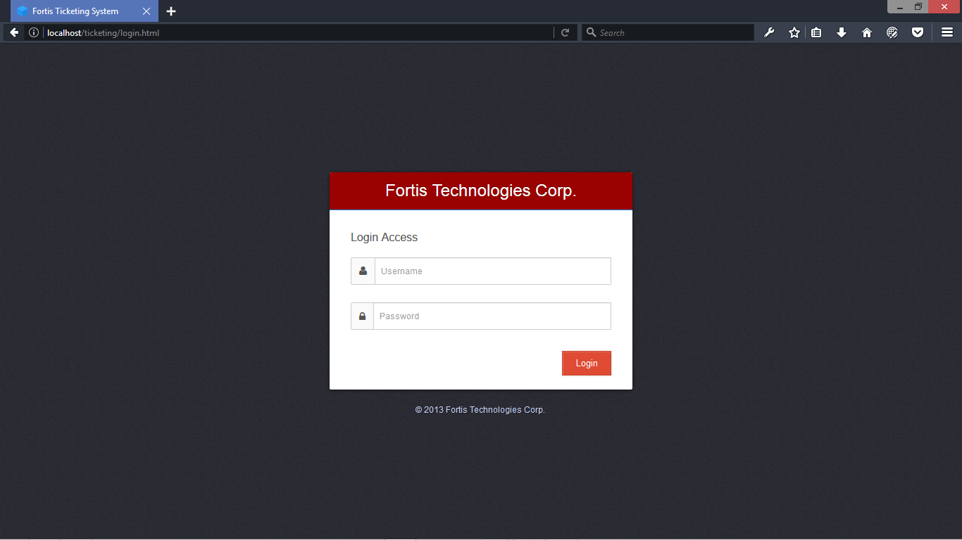

**Login Form -** This page is used to open a session with an account that is already created.

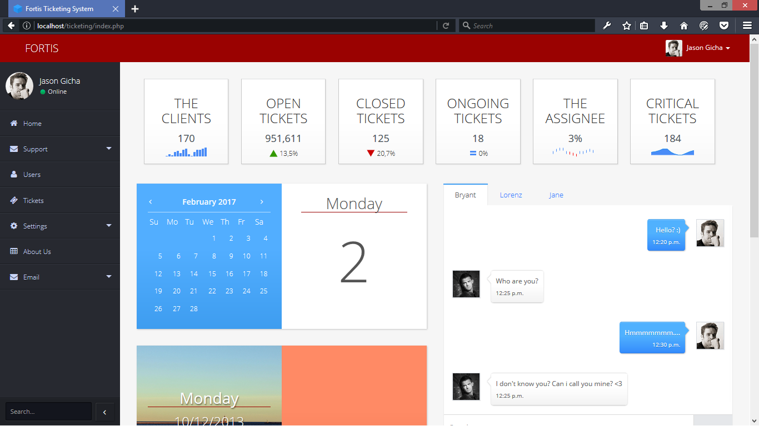

**Admin Index -**This Admin Index Module will use to see and to manage the system.

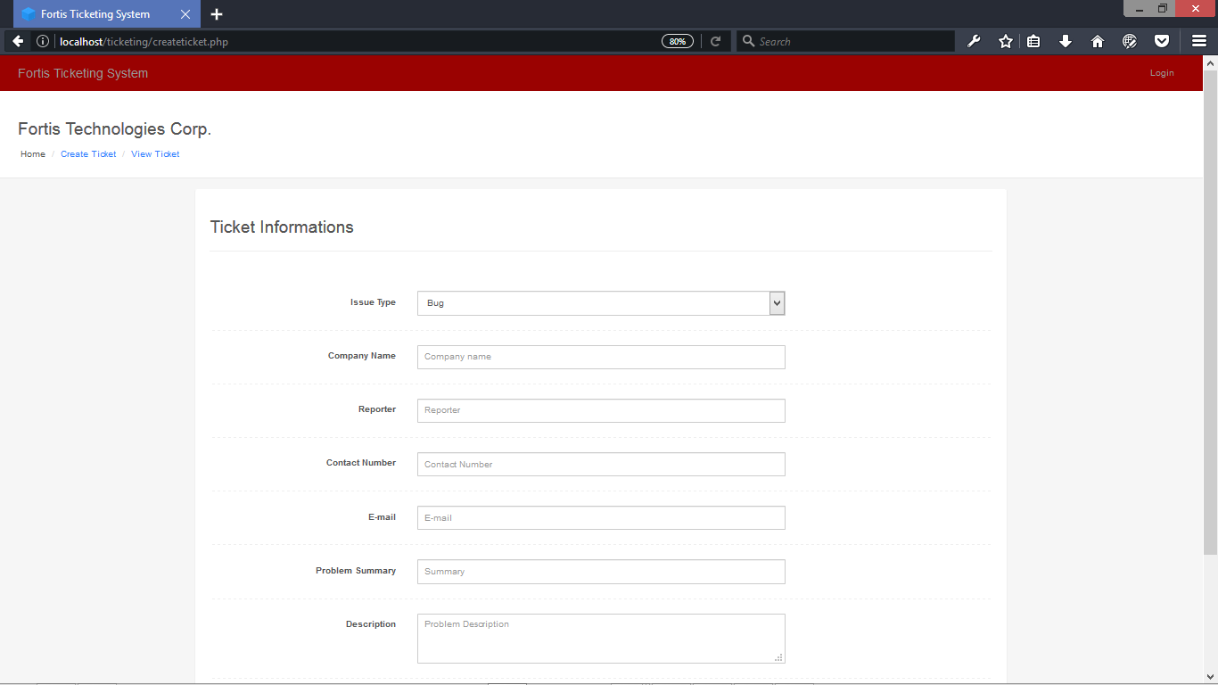

**Create Ticket -** This Create Ticket Module can create ticket that will be use for transaction with the company

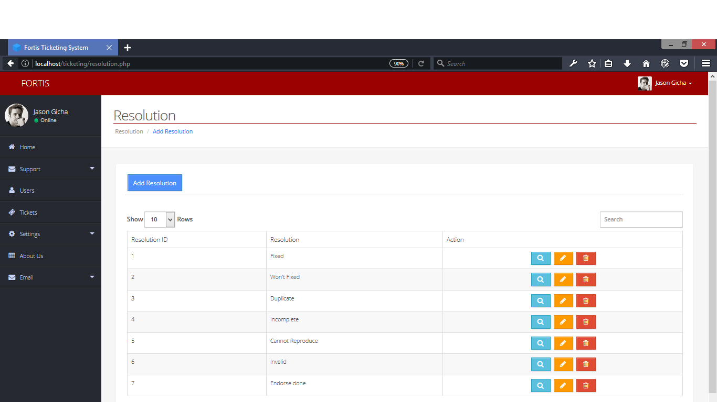

**Setting Resolution -** This Setting (Resolution) Module can add, edit, and delete resolutions.

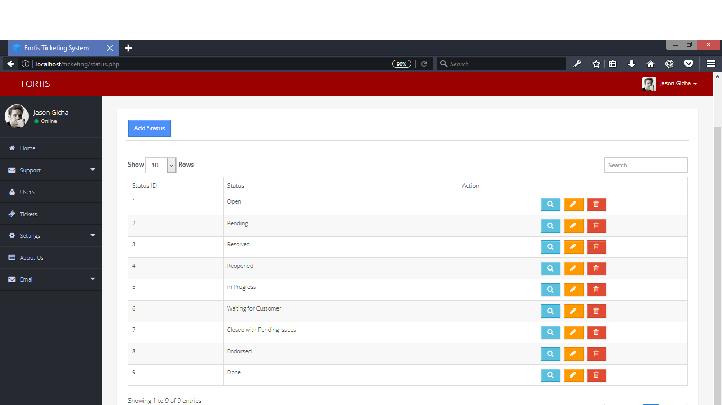

**Setting Status -** This Setting (Status) Module can add, edit, and delete status.

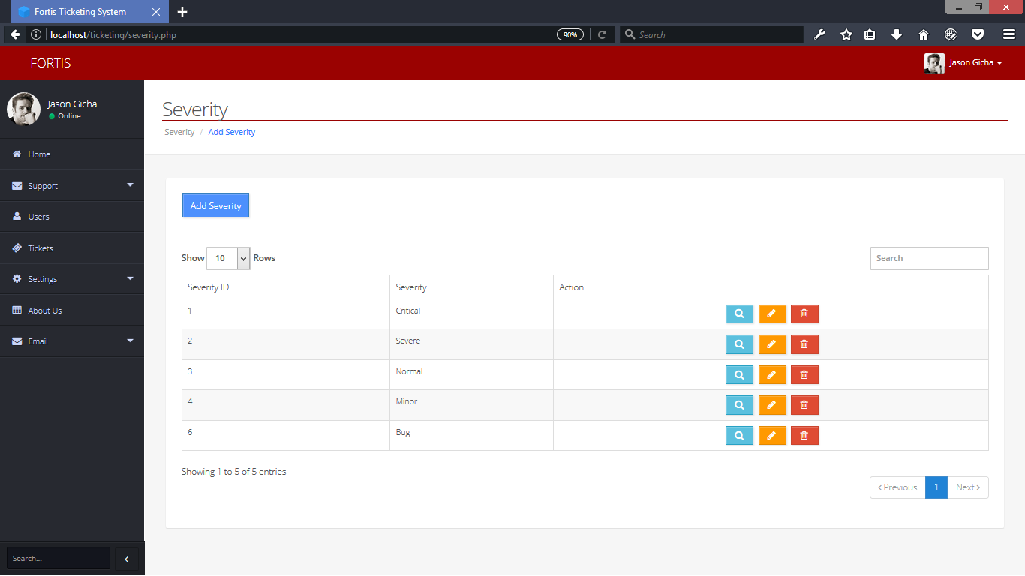

**Setting Severity -** This Setting (Severity) Module can add, edit, and delete severity.

**Implementation plan**

|  |  |  |  |
| --- | --- | --- | --- |
| **STRATEGY** | **ACTIVITIES** | **PERSON’S INVOLVED** | **DURATION** |
| Approval from the Fortis Technologies  Administrator | Letter’s for the Administrator for approval | Researchers, Administrator | 1 Day |
| System installation | Installation of the system to Fortis Technologies | Researcher’s Administrator | 5 Hours |
| Information Distribution | User’s guide | Administrator, Developers | 1 Day |
| Testing | Hands on Training and Lectures | Administrator, Developers | 7 Days |